Non-fiction Transgender-themed Books for Adults
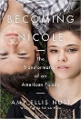
Becoming Nicole: The Transformation of an American Family. Amy Ellis Nutt. 2015. Captures the inspiring true story of identical twins, one of whom is transgender, and a family’s journey to acceptance.
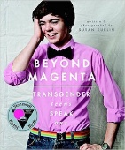
Beyond Magenta: Transgender Teens Speak Out. Susan Kuklin. 2014. (Middle-school – Adult) Profiles six transgender or gender-neutral young adults with interviews and photos. Each discussion and disclosure, whether joyful or heartbreaking, is completely different from the other because of family dynamics, living situations, gender, and the transition these teens make in recognition of their true selves.
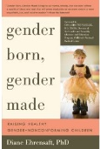
Gender Born, Gender Made: Raising Healthy Gender-Nonconforming Children, Diane Ehrensaft, 2011. A guidebook for the parents and therapists of children who do not identify with or behave according to their biological gender. Encourages caregivers to support gender-variant children as they explore their gender identities.
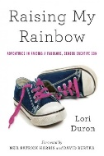
Raising My Rainbow: Adventures in Raising a Fabulous, Gender Creative Son. Lori Duron. 2014. A frank, heartfelt, and brutally funny account of her and her family's adventures of distress and happiness raising a gender-creative son. Whereas her older son, Chase, is a Lego-loving, sports-playing boy's boy, her younger son, C.J., would much rather twirl around in a pink sparkly tutu. Based on Duron’s popular blog.
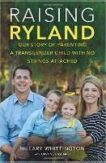
Raising Ryland: Our Story of Parenting a Transgender Child with No Strings Attached. Hillary Whittington. 2016. Hilary first told Ryland’s story in a short video for the teachers in his new school as he began kindergarten. The video soon went viral. In this moving account, you are now taken on the path of his parents as they transform their understanding of gender and learn take the many steps needed to support the life of their child.
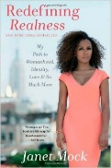
Redefining Realness: My Path to Womanhood, Identity, Love & So Much More. Janet Mock. 2014. A memoir by the People.com editor on being young, multicultural, economically challenged, and transgender in the U.S. At fifteen, she told her family and then her teachers and classmates that she wanted to be called Janet.
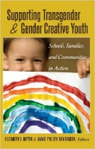
Supporting Transgender and Gender Creative Youth: Schools, Families, and Communities in Action. Elizabeth Meyer and Annie Pullen Sansfaçon (Editors) 2014.Specifically addresses issues and challenges in education, social work, medicine, and counseling as well as recommendations that are relevant for parents, families, practitioners, and educators alike.
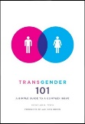
Transgender 101: A Simple Guide to a Complex Issue, Nicholas M. Teich, 2012. A readable and thorough primer on the history, terminology, types, politics, and medical and social realities of the transgender population. Written for students, professionals, friends, and family members.
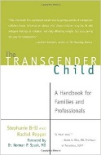
The Transgender Child: A Handbook for Families and Professionals, Stephanie A. Brill & Rachel Pepper, 2008. A comprehensive guidebook on gender variance from birth through college. What will happen when your preschool son insists on wearing a dress to school? Is this ever just a phase? How can parents advocate for their children in elementary schools? What are the current laws? What do doctors and therapists recommend?
Transgender Emergence: Therapeutic Guidelines for Working with Gender-Variant People and Their Families, Arlene Istar Lev, 2004. An excellent guide for therapists working with transgender clients and their families from a clinical and theoretical perspective.
Gender Loving Care, a Guide to counseling gender variant clients. Randi Ettner.
Transgender subjectivities: A Clinician’s Guide, Jack Dresher.
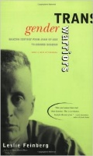
Gender Outlaw: On men, women, and the rest of us, Kate Bornstein. No holds barred memoir of gender transition by a fierce and passionate transwoman.
Transgender Warriors: Making History from Joan of Arc to Dennis Rodman, Leslie Feinberg, 1997. In this personal journey through history, the author uncovers persuasive evidence that throughout history there have always been people who crossed the cultural boundaries of sex and gender.
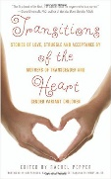
Transitions of the Heart: Stories of Love, Struggle and Acceptance by Mothers of Transgender and Gender Variant Children, Rachel Pepper (Editor), 2012. A collection by more than 30 mothers of diverse backgrounds and ages provides a window into what mothers of gender non-conforming children and adults really think and feel about their children and their own journey of change.
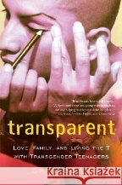
Transparent: Love, Family, and Living the T with Transgender Teenagers, Cris Beam, 2008. While volunteering at a school for gay and transgender kids, Cris found herself drawn into a pained and powerful group of transgirls. Both funny and heartbreaking. The girls struggle valiantly to resolve the gap between the way they feel inside and the way the world sees them.

Helping Your Transgender Teen: A Guide for Parents, Irwin Krieger, 2011. Krieger, as a clinical social worker, has years of experience helping transgender teens. Although written for parents, this book is useful for pediatricians, therapists, educators and others who work with teenagers and young adults.
True Selves: Understanding transsexualism, Brown and Rounsley. An accessible read that explains and discusses the experiences of transgender people using narratives.

My Gender Workbook, Kate Bornstein. A great way for teens and adults alike to explore just what it is that gender means, and is, for them.

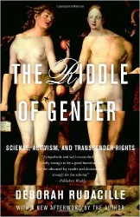
The Riddle of Gender, Deborah Rudacille. Inspired by a desire to understand a friend who came out as trans, the author has written an excellent exploration of the history of medical treatment for gender dysphoria and its social consequences. A highly engaging read, thoughtful and well-written.

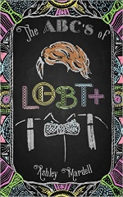
The ABCs of LGBT, Ashley Mardell 2016. This popular young YouTube host has written a frank, charming, and humorous primer on everything LGBT.

