How to Complete Enrollment for the Blugold Biomedical Exploration Camp at UW-Eau Claire:
- Create a CampDoc parent/guardian account here: http://app.campdoc.com/register/uweauclaire
- Once you have created your account and logged in, fill in information about your participant/child. Enter their information on the “New participant” page.
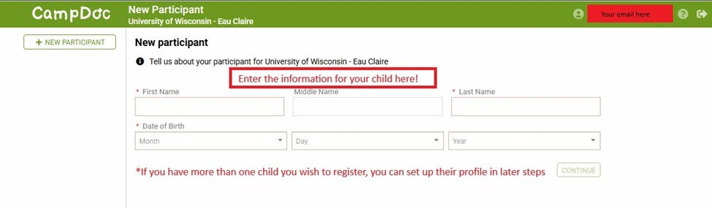
  - (You will be able to add more participants in later steps)

- Next, fill out the “About you” page with your (the parent/guardian) information, and click “Save”
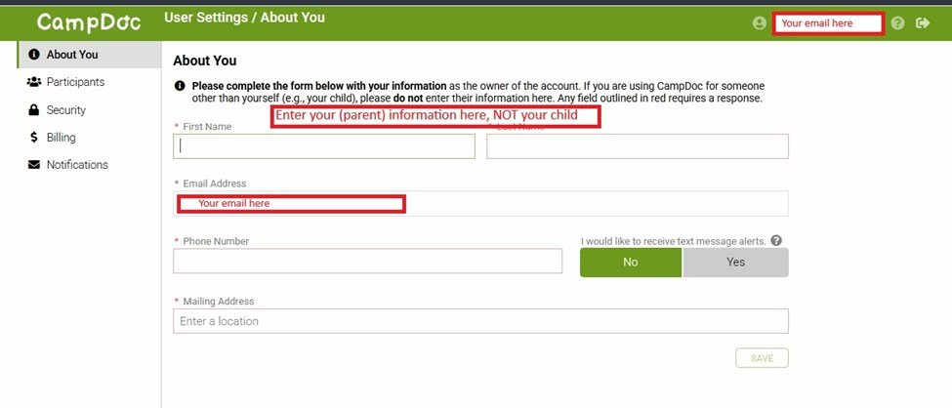

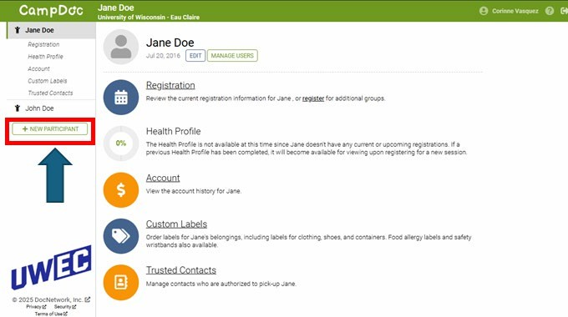
- (optional) Next, click the “New Participants” button and create a profile for any additional participant/child for which you wish to complete enrollment

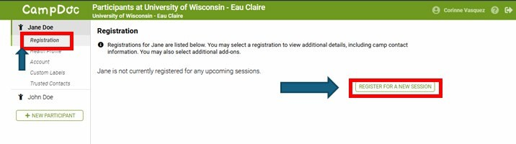
- On the left-hand menu click “Registrations” under the name of the child for which you want to complete enrollment. Then click the “Register for a new session” button

- Select your child’s grade level and hit “Continue” at the bottom of the page. All the events your child is eligible for will be displayed. Find the “Blugold Biomedical Exploration Camp”, listed under the “College of Health and Human Services. If you have trouble finding it, you can use the search bar.
- Please note each participant/child must be checked out separately.

- Use the “Continue” and “Back” buttons at the bottom of the page to complete the following steps:
  - Add-Ons: The $6 "Administrative Fee" is a once a year fee per participant which helps us fund our Youth Protection Program, ensuring safe environments for all Youth Events held at UWEC. You only pay once each year, not each camp.
  - Once you have reached the “Confirmation” page, click the checkbox to agree to the Authorization, and click “Register” to complete your registration.

- Once you have reached the “Confirmation” page, add your payment method information, click the checkbox to agree to the Authorization, and click “Register” to complete your registration.

- Once you have completed the registration process, you will be asked to complete a Health Profile for your child. Use the “Previous Step” and “Next Step” buttons to navigate the pages of the health profile. Completed fields and pages will be indicated with green checks, and incomplete fields and pages will be indicated with a red circle. The percentage at the bottom of the page will indicate the completion level of the Health Profile.

  - Please note, after you have registered for the Academy, you will be emailed every day to complete the Health Profile until the completion of the profile is 100%.
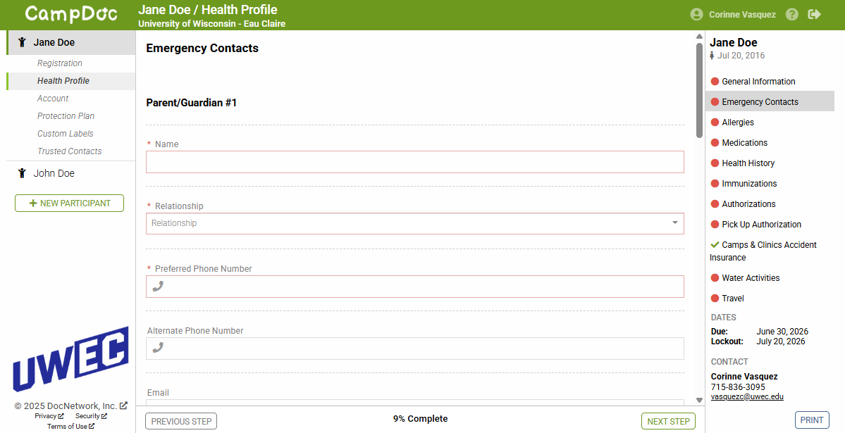

FAQ:

Why am I being charged a $6Administrative Fee?

The $6 "Administrative Fee" is a once a year fee per participant which helps us fund our Youth Protection Program, ensuring safe environments for all Youth Events held at UWEC. You only pay once each year, not each camp.

What information is collected through CampDoc?
- Camper Information
- Emergency Contact
- Camper Pick Up Authorization
- Dietary Needs
- Allergies and Intolerances
- Health History
- Health and Behavioral Background
- Medications
- Insurance
- Health Care Provider/Immunizations
- Authorizations
- CampDoc Insurance (optional)

Will this information be secure?
CampDoc offers a secure, encrypted and password-protected site to ensure the privacy of your child’s health information. Please see CampDoc’s Privacy Policy and Security Policy for additional information.

