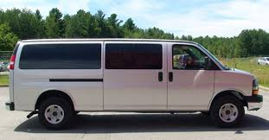
12/15 Passenger Van Training
Studies conducted by the National Highway Traffic Safety Administration (NHTSA) reveal that loaded 15-passenger vans have significantly higher risk of rollover than passenger cars and light trucks. Driving large vans requires skill and experience from the operator, with little or no margin of error.

UW-Eau Claire, UW-River Falls, and UW-Stout jointly would like to announce a new opportunity developed in coordination with Chippewa Valley Technical College (CVTC). 12/15 Passenger Van training courses will be available to qualifying university employees. Trainings will consist of classroom and behind-the-wheel instruction from trained CVTC personnel.

More information on dates and locations are below. Interested participants from all three universities are invited to sign up for the training (capacity is limited). Registration and other pricing details about this program can be found here.

October 26, 2022
8:00am -3:00pm
CVTC – Eau Claire

Contact your Risk Management Department with additional questions.

