Direct Payment Instructions – Each invoice needs a separate direct payment.

Sign Into ShopUW+ as a Requester The link to login is located here: https://shopuwplus.wisc.edu/

PLEASE USE ALL CAPS WHEN ENTERING INFORMATION
If the screenshots are too small to read, enlarge your screen with the toggle in the lower right hand corner of your screen.

Scroll down the Home Page to Forms:
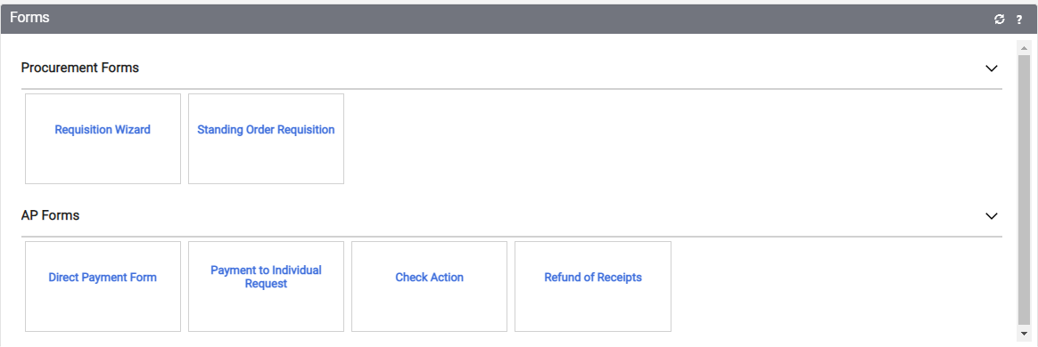
Click on the Direct Payment Form box.
You will be brought to this screen:

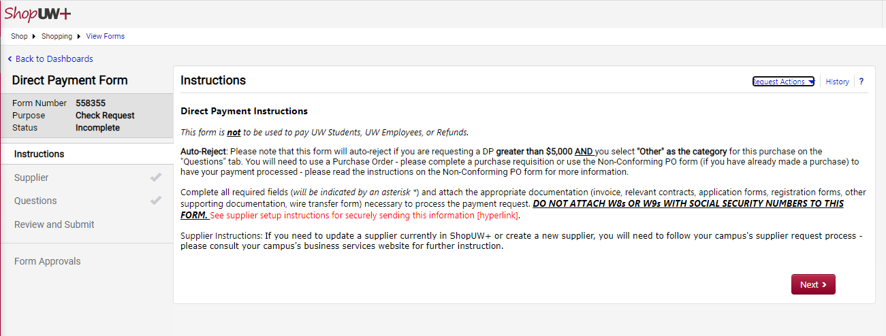
Read the Instructions, and if the invoice you are trying to pay matches the instructions, click Next.

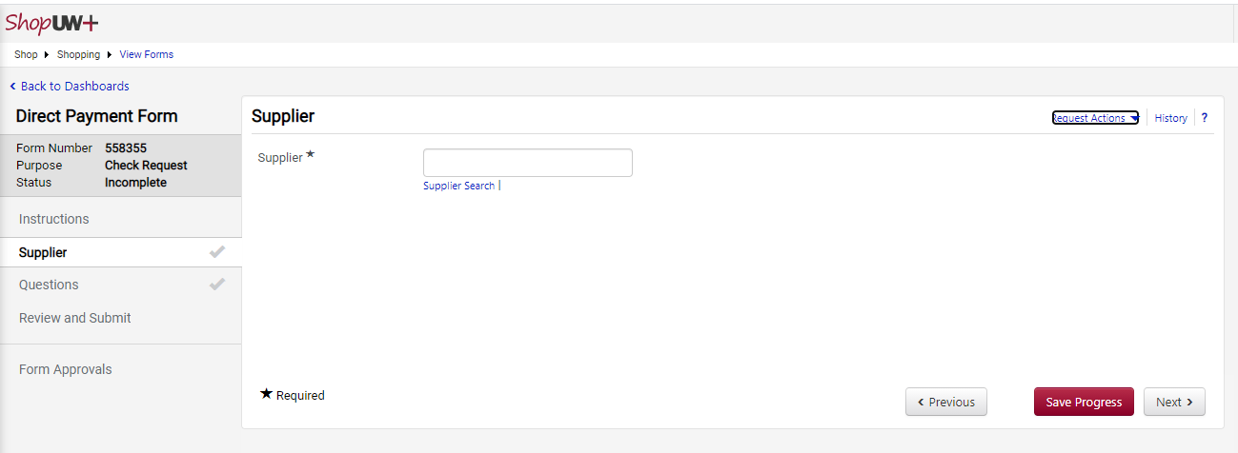
Type your supplier’s name into the search field. You may get more than one to come up – choose your supplier. If the supplier does not come up, we will need to collect a W9 to get them added before you can process a direct pay. Please contact me @ kuberrca@uwec.edu

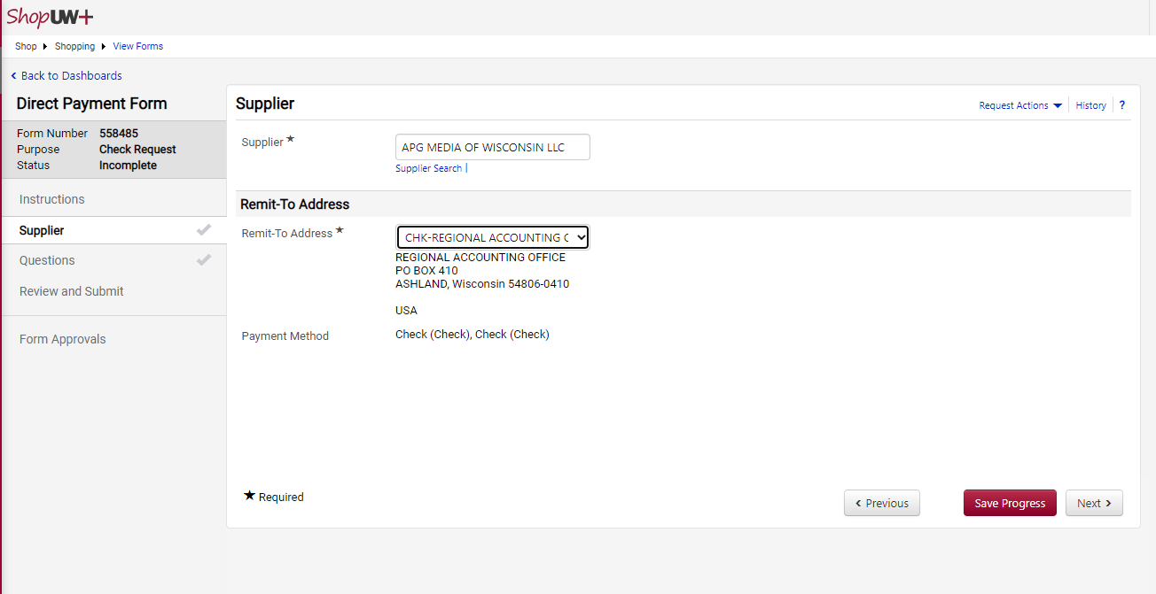
The drop-down next to the Remit To Address will access other addresses on the Supplier file if you need to select a different address. – IF THE ADDRESS IS NOT LISTED, PLEASE CONTACT ACCOUNTS PAYABLE PRIOR TO ENTERING THE DIRECT PAYMENT.
Click Save Progress and then click Next, or just click Next.

For my payment, I entered (note this is in the test environment with fake information) Full screenshots below of what I entered.
Payment Information – Choose the category that describes your payment.
Note: Category – Other – Please note that this warning comes up:
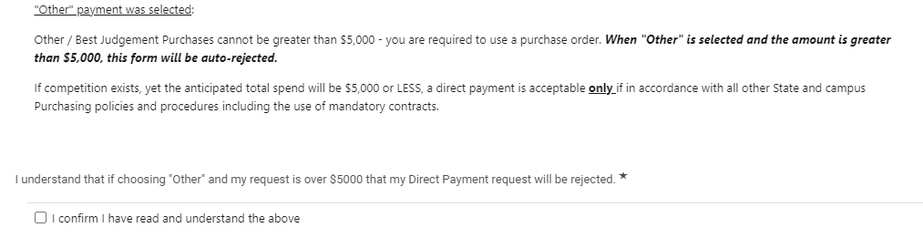
You will need to confirm that warning if you choose “Other”.
Invoice Details:
Invoice number – Invoice number from the invoice (If no invoice number use DP and date of invoice DPMMDDYEAR + SUPPLIER NAME – Example: DP04012021 APG MEDIA
Description - Advertising of Summer Camps
Currency – USD
Amount – 100.00
Invoice Date – 04/01/2021 – Invoice date from the invoice
Deferred Payment Date – You will probably never use this. That would be if you didn’t want the payment to go until a later date. Please talk to me if you have something you think should go later before using this.
Commodity Code – Click on the arrow for choices – I choose 18 Miscellaneous Commodities and Services MAKE SURE TO USE 2 DIGITS – EXAMPLE: 01 (it will not recognize 1)
Foreign Payments: Wire Transfer – You would rarely use this feature. – I choose No
If you did have a wire payment and choose Yes
This screen would pop up and you would upload a wire form.
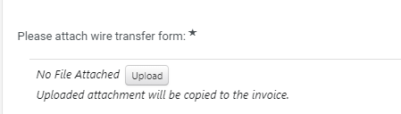
Business Purpose - Advertising of Summer Camps
Attachment – Click on the Upload Button
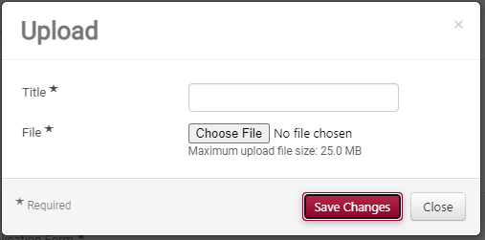
You can give your attachment a name and upload a document here. (Please note you can only upload 2 documents. You may need to combine some information in one upload if you have multiple attachments.) Save Changes

Other – same instructions, if you have an additional attachment.
Save Progress.

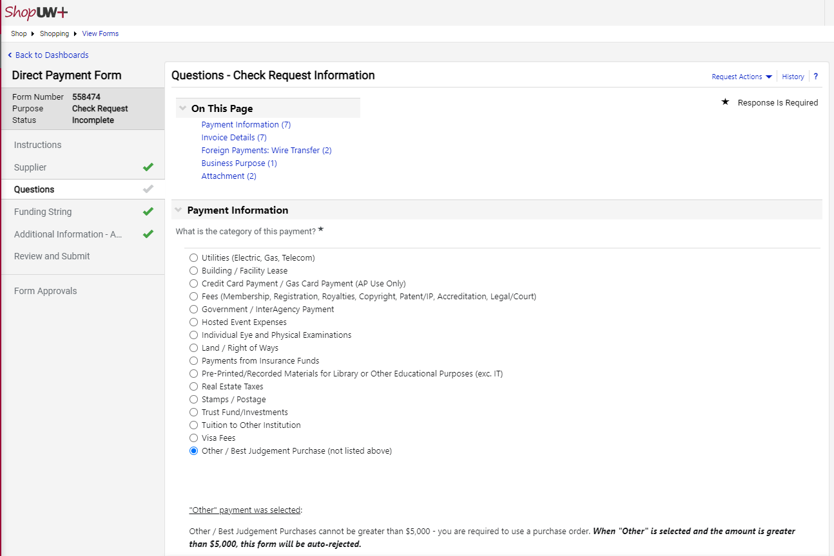
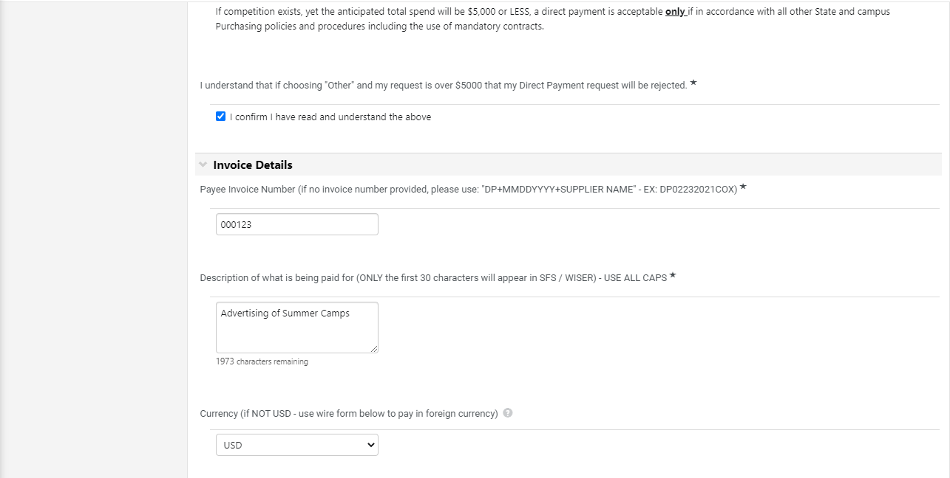
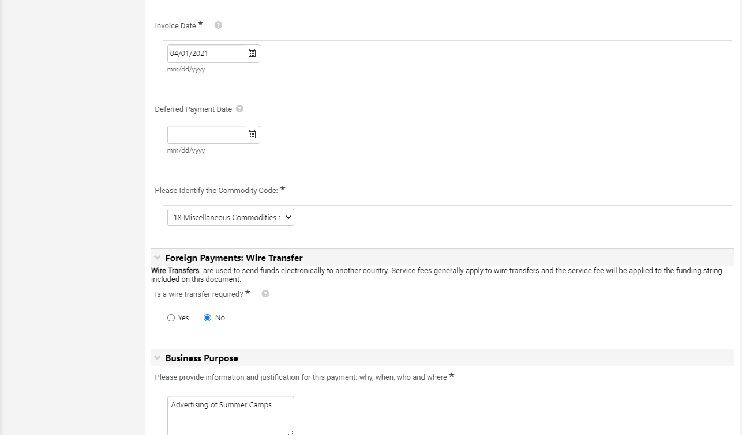
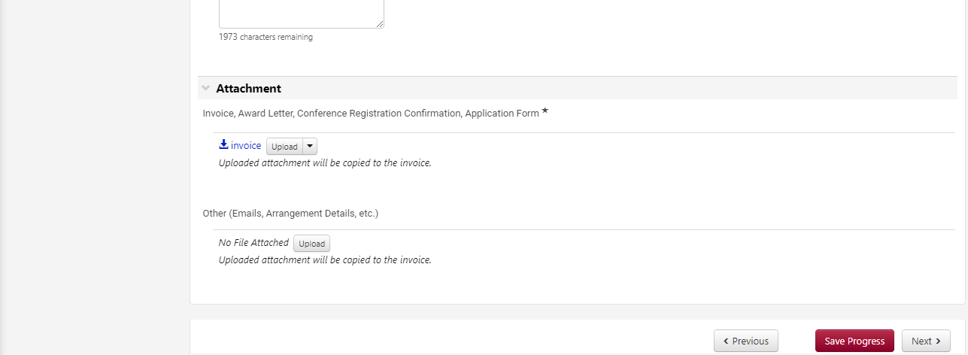

Click Next
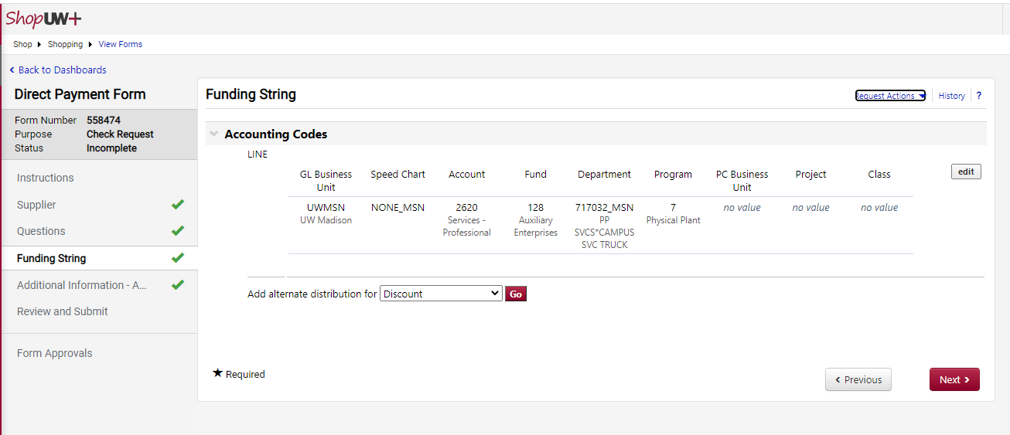
If you have a default funding string set up in your profile, it will default to that account string. If you need to edit your funding string, you can do it here.
If you do not have a default funding string, enter as follows:
GL Business Unit = UWEAU
Speed Chart = NONE_EAU
Account Code = 4 digit code see Common Account Codes
Common Account Codes: 3100-Supplies); 2623-Miscellanous services; 3740-Advertising; 2620-Professional services (use this for things like interpreting) Memberships 3730 . For a full list of codes - https://www.wisconsin.edu/financial-administration/account-codes/ OR, just send an email and I can give one to you. kuberrca@uwec.edu
Funding= 3 digit funding code
Department=your 5 digit DeptID _EAU Example: 717032_EAU
PLEASE NOTE THAT ALL DEPARTMENTS NEED _EAU AFTER THE NUMBER (my screenshot is from the test environment and we were using Madison, so that is why the screenshot has _MSN – ours will always be _EAU.)
Program Code=the program code for the funding string you are using.
PC Business Unit=UWEAU (YOU ONLY FILL THIS IN IF YOU HAVE A PROJECT CODE – It should self-populate after you enter the Project Code)
Project Code=your department’s 3 alpha 4 digit project code with _EAU at the end (example AAB1234_EAU), if any – NOT ALL DEPARTMENT USE THESE.
Class – Only a few Account Codes need this filled in. If your Account Code is in the 2100 or 2800 range of numbers (travel- VERY few invoices come in Direct Pay – most are handled in Travel Reimbursement – call or email if you have something travel related.)

Click Next

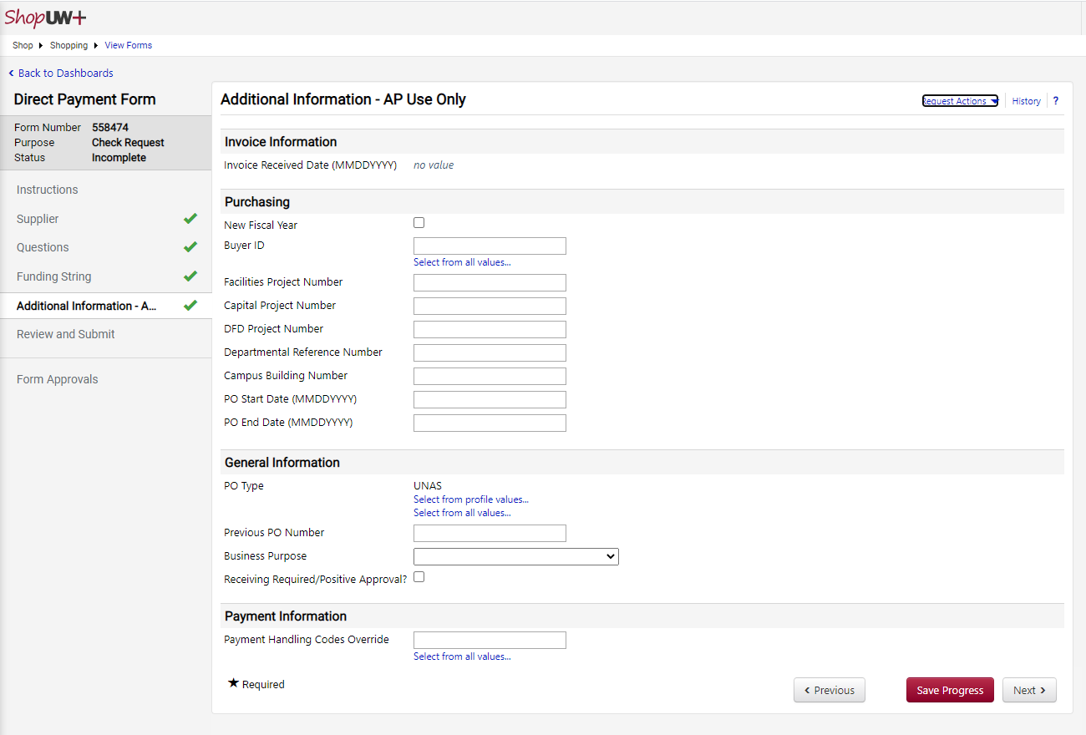
DO NOT ENTER ANYTHING ON THIS PAGE – click Next

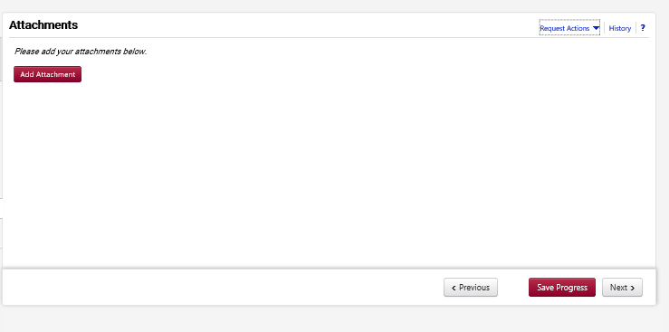
You can add more attachments here if needed. Otherwise, click next.

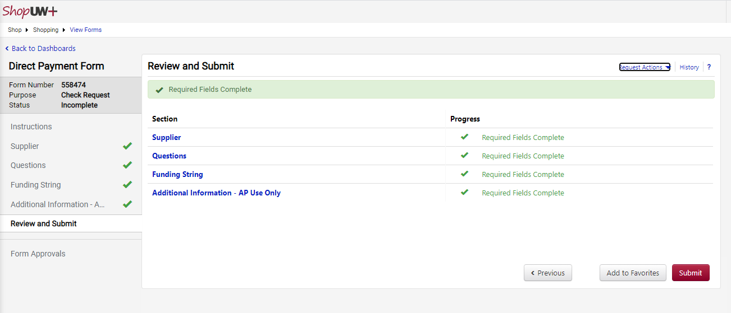
Click Submit
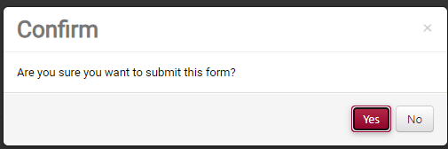
Confirm Yes
