Leg Stretches:
Knee Hugs
- Do not round back
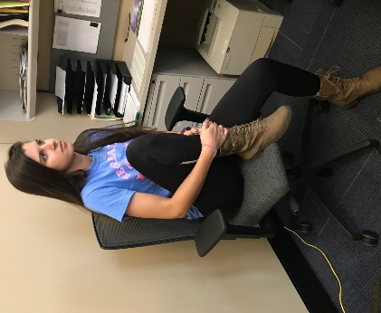

Hamstring Stretch
- Keep back neutral
- Bend at the hips
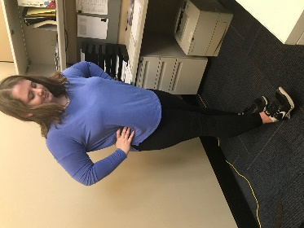

Lunge Stretch
- Don’t allow front knee to pass toes
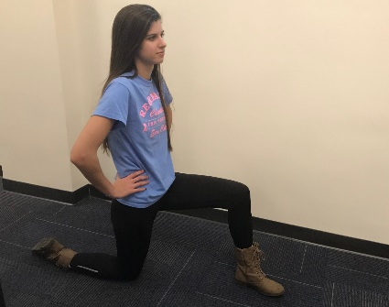
- Keep hips neutral by engaging glutes

More exercises may be found
on our website.

Need an ergonomics assessment?
Contact us!
Email: ERGO@uwec.edu
Phone: 715-836-3999
http://www.uwec.edu/LPS/
These stretches should not be done if any pain is experienced. If you have concerns about discomfort, contact your physician before doing any exercises or stretches.

Risk Management & Safety
Ergonomics

Desk Stretches

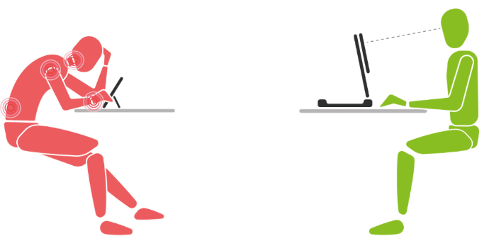

Wrist Stretches:
Wrist Flexion and Extension
- Straight elbows
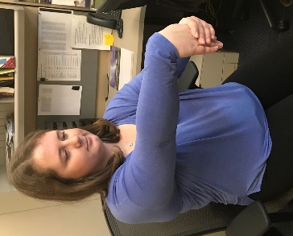
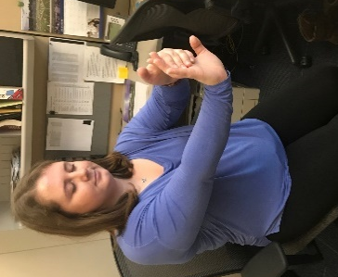

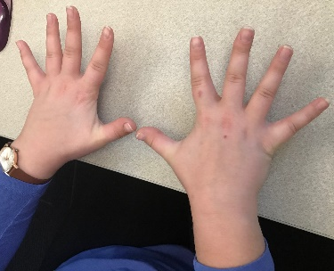
Palm Spread

Ankle Roll:
- Clockwise and counter-clockwise

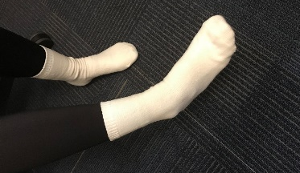

Arm Stretches:
Arm Hugs
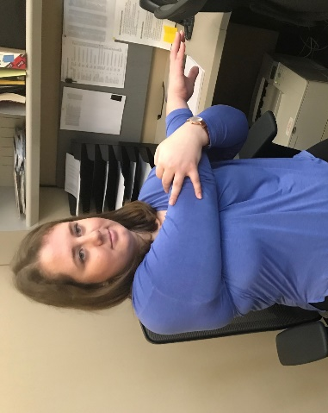
- Keep arm parallel to ground
Triceps Stretch
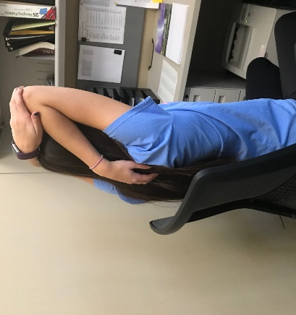
- Do not arch back

Pec Stretch
- Do not arch back
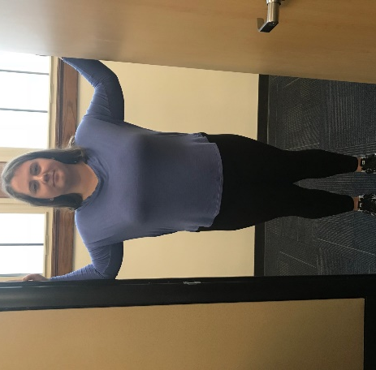
- Squeeze shoulder blades together

Shoulder Rolls
- Forward and backward
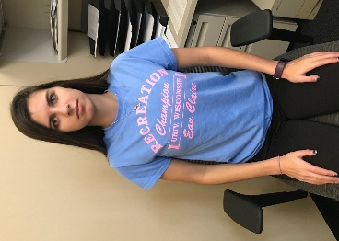
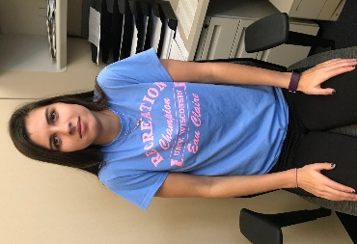

Overhead Reach
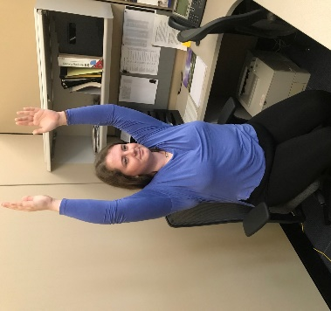
- Do not arch back
- Straighten arms as much as possible

Arm Circles
- Clockwise and counter-clockwise
- Slow and controlled
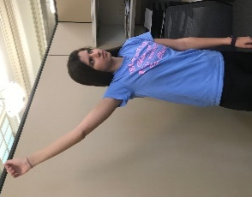

*These stretches should be done once per day
*Complete each stretch twice for 15 seconds
*Complete rotational exercises for 10 cycles

